**SQAT Final Term Project**

**Software Test Plan for Parental Security Application**

**Prepared by:**

|  |  |
| --- | --- |
| **Name** | **ID** |
| **Sarker, Md. Fazley Rabbi** | **19-39444-1** |
| **Tanzina Azmarin Sharna** | **19-40322-1** |
| **Mozumder, Shakrin Jahan** | **19-39886-1** |
| **Tahia, Sumaiya Jahan** | **19-40584-1** |

**Under the supervision of**

**Md. Anwarul Kabir**

**Associate Professor**

**Prepared by Md. Fazley Rabbi Sarker, Azmarin Sharna, Shakrin Jahan, Sumaiya Jahan**

**Department of Science and Technology**

**Date:6/5/2022**

**TABLE OF CONTENTS**

1.0 INTRODUCTION

OBJECTIVES AND TASKS

• Objectives

• Tasks3.0 SCOPE

Testing Strategy

• Alpha Testing (Unit Testing)

• Integration Testing

• System Testing

• Performance and Stress Testing

• User Acceptance Testing

• Batch Testing

• Automated Regression Testing

• Beta Testing

5.0 Hardware Requirements

• Environment Requirements

• Main Frame

• Workstation

7.0 Test Schedule

8.0 Control Procedures

9.0 Features to Be Tested

10.0 Resources/Roles & Responsibilities

11.0 Schedules

12.0 Dependencies

13.0 Risks/Assumptions

14.0 Tools

**1.0 INTRODUCTION**

**OBJECTIVES AND TASKS:**

**Objectives:**

Caring for aging parents must be the priority of every child, regardless of how pre-occupied they may be. We should make more effort to build a truly caring society which is willing to help the needy and less fortunate, especially our senior citizens. The younger generation today must learn to appreciate their parents and make it a culture and priority to care for them as they age. However, there are some who tend to get so carried away with their career and family commitments that they neglect their duties. No matter how busy you are, children have a responsibility to take care of their elders.

**Tasks:**

• Parents and children have registered accounts with information of their voter ID. Each parent's account has their daily routine/needs and medical reports.

• Users will receive push notification according to the schedule of the parent's important daily needs and medicines. Parents can signal their children after taking medicines by pressing a button. If he/she fails to do so their children will be warned and receive emergency alerts to assist the parents.

**3.0 Scope:**

The ‘Parental Security Application’ testing will consist of Unit, System, Integration and Acceptance test levels. However, with the budget constraints and timeline established, most testing will be done by the test manager with the development teams’ participation.

**Testing Strategy:**

• **Alpha Testing (Unit Testing):**

Unit testing is a type of testing in which individual units or functions of software testing. Its primary purpose is to test each unit or function. A unit is the smallest testable part of an application and it is also white box testing. When a developer completes a module, the developer compiles that module to ensure the module is working. It mainly has one or a few inputs and produces a single output.

• **Integration Testing:**

Integration testing aims to check the correctness of communication among all the different units and their interactions. Integration testing is a type of testing meant to check the subsystems unit into one standard system and code compliance with the requirements. It is performed by the test manager and development team leader with assistance from the individual developers as required.

• **System Testing Definition:**

This testing occurs when the integration testing has been done. Here it tests the overall system operations as a whole, typically from a customer’s perspective. System testing verifies that an application performs tasks as designed. This step, a kind of black-box testing, focuses on the functionality of an application. System testing, for example, might check that every type of user input produces the intended output across the application.

• **Performance and Stress Testing:**

Performance Testing is a type of software testing that is carried out to determine system performance in terms of sensitivity, reactivity and stability under a particular workload. Stress Testing: Stress testing is a type of software testing that verifies the stability and reliability of the system.

• **User Acceptance Testing:**

User Acceptance Testing (UAT) is a type of testing performed by the end user or the client to verify/accept the software system before moving the software application to the production environment. UAT is done in the final phase of testing after functional, integration and system testing are done.

• **Batch Testing:**

In order to evaluate the **Quality, Safety and Efficacy** of the given drugs, Quality Assistance offers full capabilities for the**control of drug substances, drug products, raw materials and excipients**, in the context of in-process control, technical, (non-)clinical and commercial batches. Our qualified teams will work closely with you, dealing with your project and completing all batch documentation to expedite sale, supply and export.

• **Automated Regression Testing:**

Automated Regression Testing a software testing technique that utilizes computer-based tools and techniques in testing software after it has been changed or updated.

* **How to do Automation Regression Testing?**

1. Software change analysis at this stage a developer estimates which system component will be changed as well as the extent of the change.
2. Software change impact analysis.
3. Building a regression testing strategy.
4. Creating a test suite.
5. Executing regression tests.
6. Reporting.

**Beta Testing:**

Beta testing is one of the final steps in your software development lifecycle (SDLC) before a product goes live. Also referred to as user testing or customer validation, beta testing aims to ensure that end users are satisfied with a software product before you make it generally.

**5.0 HARDWARE REQUIREMENTS:**

Computer Modems

• **ENVIRONMENT REQUIREMENTS**

• **Main Frame:**

A web application security frame that can incorporate expertise into an engineering activity, for example, a threat modeling activity, is provided. The novel web application security frame component can be applied to a threat modeling component to converge knowledge into the activity by identifying categories, vulnerabilities, threats, attacks and countermeasures. Additionally, a context precision mechanism can be employed to automatically and/or dynamically determine a context of a web application environment. This context can be used to automatically generate an appropriate web application security frame component.

• **Workstation:**

Parental controls are features or software that allow you to monitor and restrict what a person does online. There are a wide variety of programs that do such things as blockand filter websites and content, record their activities, limit their time online, and view their browsing history and communications.

**7.0 TEST SCHEDULE:**

The following testing activities have been scheduled in the project plan. We have used the cloud-based platform “Monday.com” to create a gantt chart for our project schedule. The project plan timetable specifies the particular dates and hours for each task. In collaboration with the development and test team leaders, the project manager will coordinate the employees required for each task, test team, development team, management, and customer.

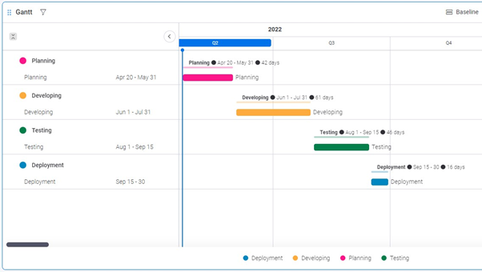

Fig 6: Gantt chart for project schedule

**8.0 Control Procedures:**

**Problem Reporting:**

Document the procedures to follow when an incident is encountered during the testing process. If a standard form is going to be used, attach a blank copy as an "Appendix" to the Test Plan. In the event you are using an automated incident logging system, write those procedures in this section.

**Change Requests:**

Document the process of modifications to the software. Identify who will sign off on the changes and what would be the criteria for including the changes to the current product. If the changes will affect existing programs, these modules need to be identified.

**9.0 FEATURES TO BE TESTED**

* System Features

**1.Registration:**

**Functional Requirements:**

* The software has a registration option. The registration procedure is for child user in this system. Child will sign in to the software by doing registration. It will take personal information such as name, email address, Country.
* A verification code will be sent to the email id for verification.
* If the verification is not successful, the verification code will be provided again.

**Priority level:** High.

**Precondition:** A valid email address.

**2.Create Profile**

**Functional Requirements:**

* After signing in, the child user will create two profiles One is child user profile & another is parents user profile.
* In both profile, name, mobile number, valid NID number, age, location is needed.
* After creating the profile, both profiles will be connected.

**Priority level:** High.

**Precondition:** Registration & sign in.

**3. Schedule:**

**Functional Requirements:**

* After creating the profile, the child will schedule the parent’s routine.
* In the schedule section there will be many options of routine like, parent’s mealtime, medicine, exercise time, any kinds of advice & other important information.

**Priority level:** High.

**Precondition:** Create profile.

**4. Notification**

**Functional Requirements**

* Following the schedule, a notification alarm will be ringed to parent’s device by the softeware.it will be a reminder for them to do their needed activities.
* If they don’t respond then automatically a notification will be shown to the child profile. Then they will be aware of it.

**Priority level:** High.

**Precondition:** Schedule.

**5. Update schedule & Information**

**Functional Requirements:**

* Users will be able to update or change schedules anytime.
* Users also can update other information like mail id phone number & etc.

**Priority level:** High.

**Precondition:** Registration & schedule.

**6.1 Settings & Background Options**

**Functional Requirements:**

* In the software there will be settings option for change language & also theme mode option (Dark mode & Light mode).

**Priority level:** Low.

**Precondition:** Registration & schedule.

* **System Interface:**

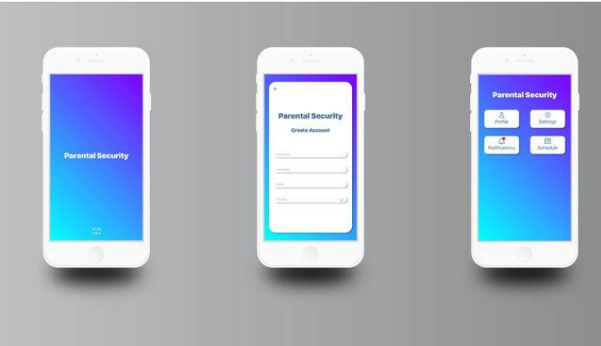

**Fig 1: App UI/UX**

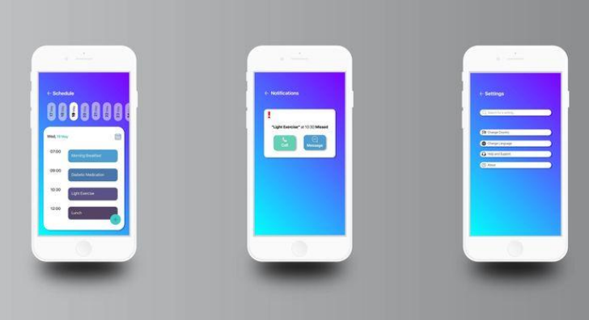

**Fig 2: App UI/UX**

**Project Requirements:**

-Total Development Time: 6 months.

- Total Working Hours needed: 1440 Hours

-10 * 8 * 18 = 1440 hours or 18 months for development

-8 * 30 = 240 hours for Testing & Debugging

-2 months for revision

-Total Budget: 1,450,000 BDT

-Resources: 4 app developers, 4 software testers, 4 Custom Built PCs, 5 Android mobile smartphones.

-LAN Connection.

-Framework: Flutter

-Language: Dart

-Database: MongoDB

**10.0 FEATURES NOT TO BE TESTED:**

We have a total of ten features in our project. Out of these ten features, two will not be tested. Those two features are:

**1. Profile Edit:** All the vital information will be cross-checked at the time of registration. So, this is not an essential feature. There will be some functions in profile edit like upload & change the user’s profile picture and change the app’s theme. Without these things, one can easily use the app.

**2. Multi-language:** By default, the language will be English. We have conducted a survey, most of the participants preferred English as their preferred language for the app. In this way, foreigners can also use the app. Nevertheless, many people preferred Bangla as the app language, so we will work on that. However, this is not a high-prioritized feature. We will not test this feature as of now.

**11.0 RESOURCES/ROLES & RESPONSIBILITIES:**

|  |  |  |
| --- | --- | --- |
| **Name** | **Role** | **Responsibilities** |
| Md. Fazley Rabbi | Project Manager | 1. Determines which of the identified problems must be solved and in what order.  2. Review all open reports each week, identifying the problems of interaction  3. Obtain the necessary literature to find deficient information about any problem. |
| Shakrin Jahan Mozumder | Test Lead | 1. Defining the testing activities, All responsibilities of test planning  2. To check if the term has all the necessary resources to execute the testing activities.  3. Prepare the report of testing activities.  4. Updating project managers regularly about the progress of testing activities. |
| Azmarin Shawrna | Test Engineer | 1.Develop test cases and prioritize testing activities.  2.Execute all the test cases and report defects.  3.Inform the test lead about what all resources will be required for software testing. |
| Sumaiya Jahan Tahia | Software Tester | 1. Designing testing scenarios for testing.  2. Perform the testing.  3. Create testing documentation and does testing-related work. |
| Shakrin Jahan Mozumder | Software Tester | 1.Creation of test designs, test processes, test cases, and test data.  2.Carry out testing as per the defined procedures.  3.Prepare all reports related to software testing carried out. |

**12.0 Schedules:**

**Major Deliverable**

* Test Plan: This document deals with what needs to be done in UAT.
* Designs: The UAT Acceptance Criteria.
* Test Cases: The values input and results expected from tests.
* Test Item Transmittal Reports: Developers handover report.
* Test Logs: The results of running the tests.
* Incident Reports: Observations of unexpected results.
* Incident Report Logs: Summary of Incident Reports.
* Test Summary Report: Summary of testing.
* The test data

**13.0 DEPENDENCIES:**

**Application Dependencies:**

* Locally attached devices. Locally attached devices can pose a clear dependency problem.
* Hard coding. Hard coding an application to a particular device in a particular location creates a potential dependency issue.
* Host name dependencies.
* Software licensing.

**14.0 RISKS/ASSUMPTIONS:**

|  |  |  |  |
| --- | --- | --- | --- |
| **Risk** | **Probability** | **Impact** | **Mitigation** |
| Error in Functions | Medium | Medium | Test the application frequently and maintain a daily backup. |
| Wrong SQL Command  for Important Data | Medium | High | Maintain security checks & backups. |
| Loss of encrypted data | Medium | High | Maintain security check and backup. |
| User’s account hacking attempt | High | High | Restrict user after three unsuccessful login attempts in an hour. |

**15.0 TOOLS:**

The tools have different approaches to testing and thus have different sets of features. We will use Flutter and Mongo dB to develop our application.

* **Unit Testing:**

Unit testing is a type of testing in which individual units or functions of software testing. Its primary purpose is to test each unit or function. A unit is the smallest testable part of an application. It mainly has one or a few inputs and produces a single output.

For darts, we must use SELENIUM as a software testing tool.

* **Integration Testing:**

Integration testing is a type of testing meant to check the combinations of different units and their interactions; subsystems unite into one standard system and code compliance with the requirements. For integration testing, we must use selenium as our testing tools. This tool is for the web.

**System Testing:** System testing verifies that an application performs tasks as designed. This step, a kind of black-box testing, focuses on the functionality of an application. System testing, for example, might check that every type of user input produces the intended output across the application. To perform System testing, we will use:

* **Selenium:** Selenium is Codeless Automation Testing Tool that provides automated testing solutions to test our website. Selenium Automates executes and manages test cases effortlessly & efficiently.

**REFERENCES:**

1. Adobe Illustrator CC 2022: [www.adobe.com/products/illustrator.html](http://www.adobe.com/products/illustrator.html)

2. Monday.com : [www.monday.com](http://www.monday.com/)

3. Selenium:[www.selenium.com](http://www.selenium.com)